

Programme Name: ________**BCS HONS**_______________________________________

Course Code: __**MATH 1023**________

Course Name: ________**Additional Mathematics**___________________________

**Mathematics Internal Examination**

Date of Submission: ______**9/17/2020**_____________

**Submitted By: Submitted To:**

Student Name**: Dipesh Tha Shrestha** Faculty Name**: SHANTA RAYAMJHI BASNET**

IUKL ID: **041902900028** Department**: LMS**

Semester**: Second Semester**

Intake**: September 2019**

Q 1 If 2nd and 5th term of a G.P. is 24 and 81 then find:

i. First and common ratio

ii. Find 10th term

iii. Find geometric series.

Answer

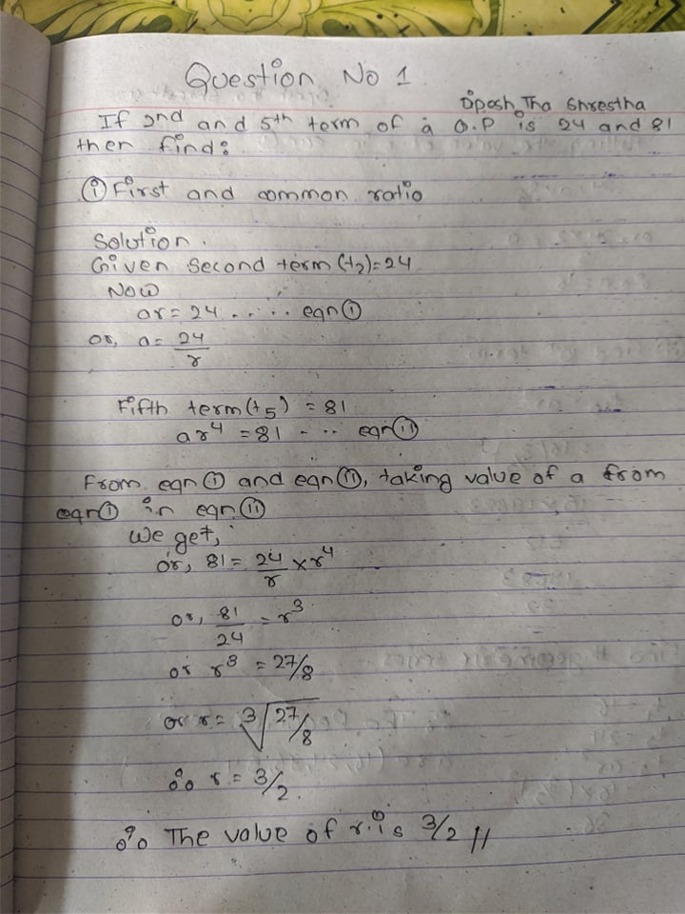

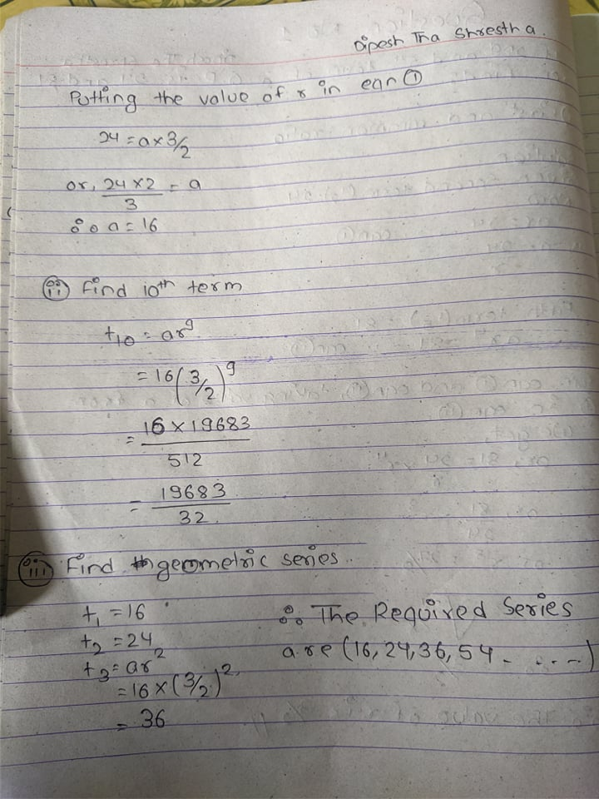

2. a. Solve the given equation by using completion of square 2x 2 + 4x − 4 = 0.

Answer=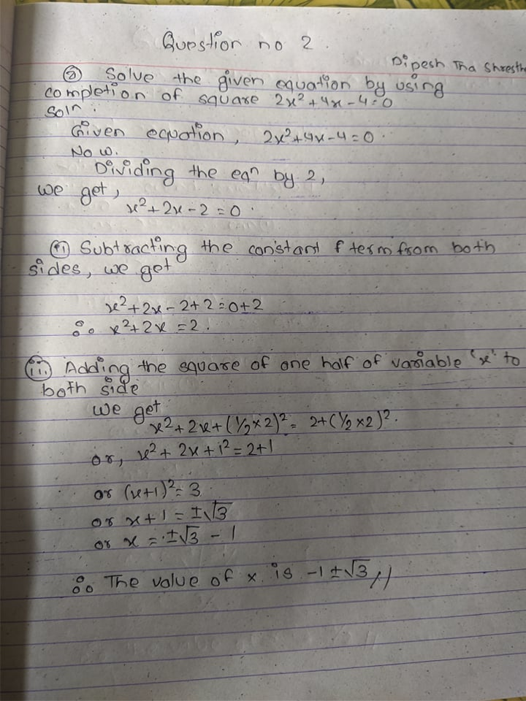

b. Find the value of k for which the root of the equation 4x2 -(k-2) x+9=0 will have two equal roots.

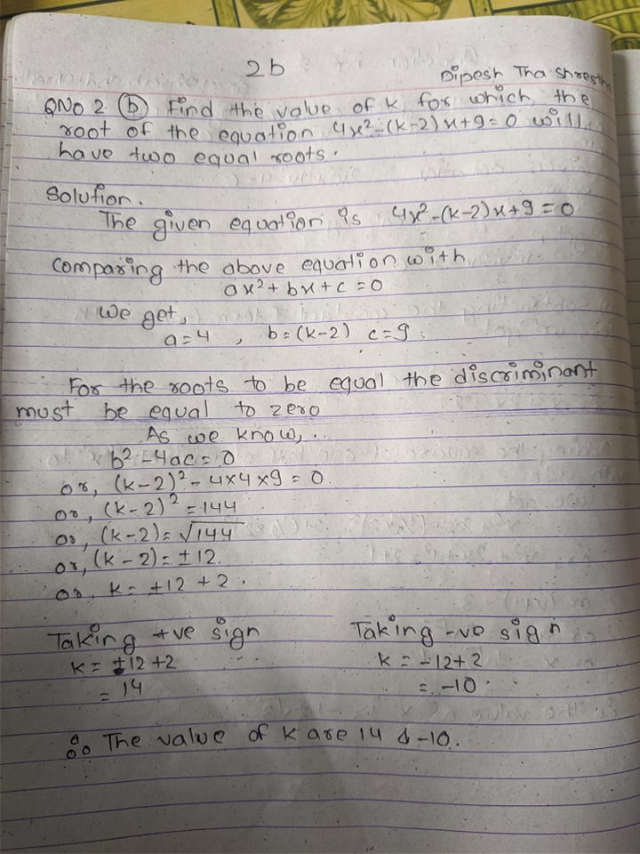

3. a. Solve for x of the given the equation: 103x – 2 = 13

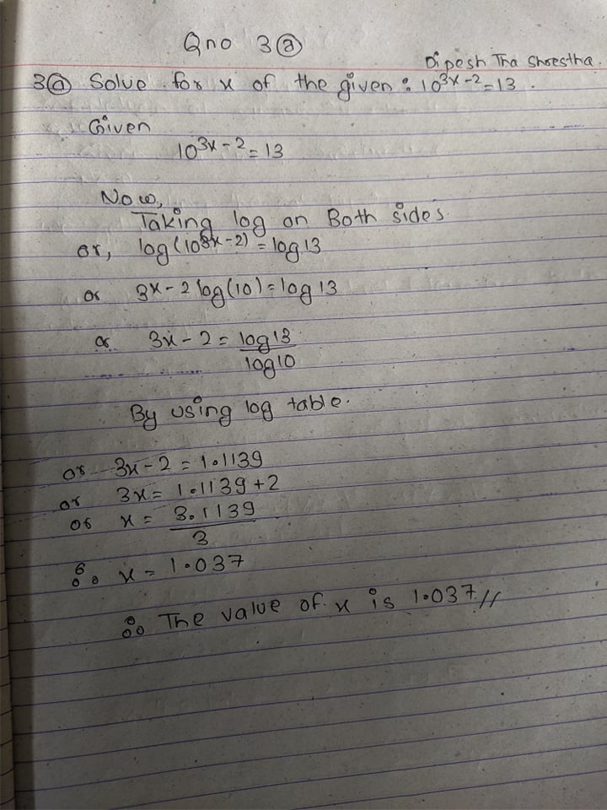

b. Convert degree into radian and radian into degree.

i. 240

ii. 2.4 radians

iii. Prove that: sin2 600+cos2 600= 1

